Finite State Machines are synchronised sequential circuits that have a finite number of states. FSM’s have multiple states and the inputs in the machine are used to determine the new state of the machine. There are two types of FSM’s, Mealy and Moore.
To make a finite state machine you must:
- Develop a model of the systems behaviour
- Design the circuit in order to implement the FSM
Also known as Finite Automata, FSM’s can only be in one state at a time which is called the current state. When FSM’s change states this is known as a transition. It occurs when the current state takes in an input triggering an event or condition causing a new current state, example: a pedestrian presses the button, the traffic light goes from green to red then red to amber and back to green.
6 tuple
- Q: finite set of states
- Σ: non-empty finite set of input alphabet
- O: finite set of symbols called the output alphabet
- δ: represents the state transition function (Q * Σ = δ)
- q0: the initial state
- X: output transition function
History of finite state machines

Warren McCulloch and Walter Pitts were neurophysiologists who were the first to put forward an account of a finite state machine in 1943 which was called “A Logical Calculus Immanent in Nervous Activity”. It had a major impact on various studies such as neural networks, theory of automata and cybernetics. This in turn created a path for two computer scientists named G,H Mealy and E.F Moore to generalise the theory to more powerful machines in 1955-1956.
Example of Finite State Machine: Simple gaming console
Game running
Player dies player clicks ‘Pause’
Game over

Game pauses

Player click ‘start’ Player clicks ‘Resume’
Game off
player turns game off player turns game off

This example shows the FSM of a simple gaming program with a finite set of outputs. The initial state (q0) is ‘ Off ‘. The transition first occurs when the user turns the game on (Game running). The player can change the current state to pause the game or die in the game. If the current state is ‘paused’ the user can turn off or click ‘resume’. If the player dies they can choose to start again or turn off the game.
Other examples:
- Student accommodation turnstiles: controls the access for students living on campus. It has two possible states, the initial state, locked and then unlocked. The only way to change the state is to have the correct key card to gain access where the state turns to unlocked and as you pass through the state shifts back to locked to limit access.
- Traffic lights: allows for the movement of traffic in congested zones. Traffic lights operate in a sequence to ensure safe progression of traffic. Green turns to amber then to red. After traffic passes we seen flashing amber then back to green. Inputs that cause a transition can either be the rotation of traffic flow or pedestrian interactions with the crossing assistance.
- Coffee machine: simple machine used to make different types of coffee. The initial state is in off, when turned on the user has a finite set of inputs that allow the user to choose between various coffee drinks. The current state alters when you chose which coffee to make, the machine carries out the instruction example: cappuccino. Once the coffee is made the FSM returns to standby mode where it waits for the next input.
Mealy versus Moore machines
Mealy machine:
- Is a machine whose outputs are determined upon its current state and current inputs.
- If the input alters, the output changes
- Generally there are less states in a mealy machine
- More hardware required for circuit implementation
- These machines are more difficult to design
- Asynchronous output generation, this means it doesn’t occur at the same time.
- Respond quicker than Moore, they react in the same clock cycle

Diagram of a mealy machine
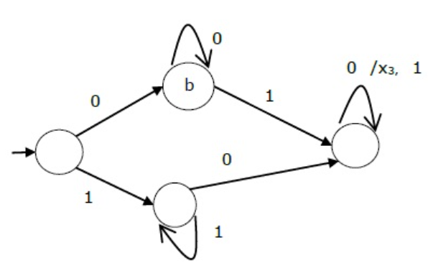

Moore machine:
- Is an FSM whose outputs depend on the present state
- If the input changed so does the output
- Generally there are more states required
- There is less hardware required for the circuit implementation
- They are easier to design
- Synchronous output and state generations, this means they happen at the same time
- More logic is required to decode the outputs which results in more circuit delays(one clock cycle later)
Diagram of a Moore machine
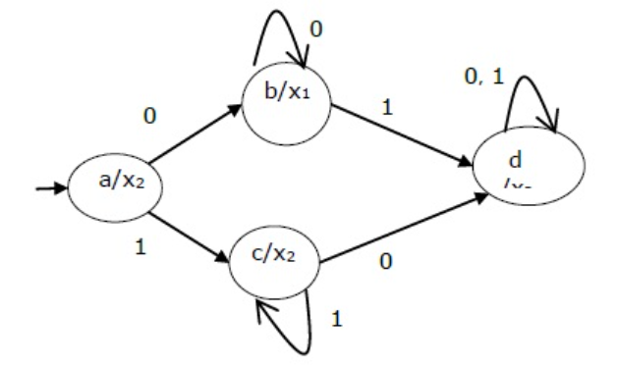

Comparison table
Mealy machine | Moore machine
More complex to design | Easy design
Outputs depend on present state and present input | Outputs depend upon the present state only
Fewer states | More states
React faster | One clock cycle delay
Asynchronous output generation | Synchronous output and state generation
More hardware required for circuit implementation (More powerful) | Less hardware required for circuit implementation

FSM example: Card Machine
State diagram pseudocode: Mealy machine (binary state diagram below)
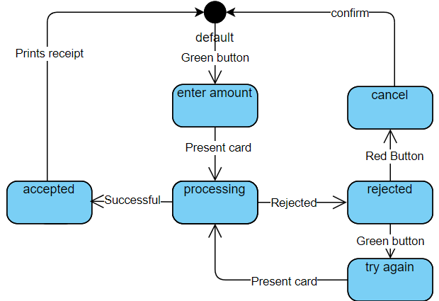
The inputs are represented on the arcs and the output is represented by where the arrow is pointing.
We give the states a unique binary number:
- Default = 000
- Enter amount = 001
C. Processing = 010
D. Accepted = 011
E. Rejected = 100
F. Try again = 101
G. Cancel = 110
The output is dependent on the input and the current state
Present state | Input U: | Input U: | Next state:  X = 0 | Next state:  X = 1 | C  X = 0 | C  X = 1 | V2V1V0  X = 0 | V2V1V0  X = 1
A(000) | 0 | 1 | A | B | 1 | 0 | 000 | 001
B(001) | 0 | 1 | B | C | 0 | 0 | 001 | 010
C(010) | 0 | 1 | D | E | 0 | 0 | 011 | 100
D(011) | 0 | 1 | D | A | 0 | 1 | 011 | 000
E(100) | 0 | 1 | F | G | 0 | 0 | 101 | 110
F(101) | 0 | 1 | F | C | 0 | 0 | 101 | 010
G(110) | 0 | 1 | G | A | 0 | 1 | 110 | 000
State Table: Blue = 0 input, Red = 1 input

State diagram using binary number representation:
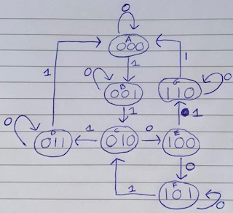

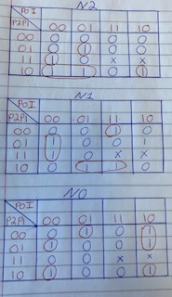
Karnaugh Map:
- We construct a Karnaugh map for N2,N1 and N0 grouping the 1’s together (can only group in 1,2,4,8 etc)
- We used the state table to help create the k-maps.

Next State Logic
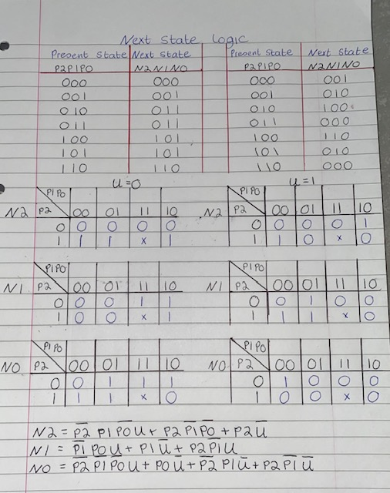

State Logic implementation
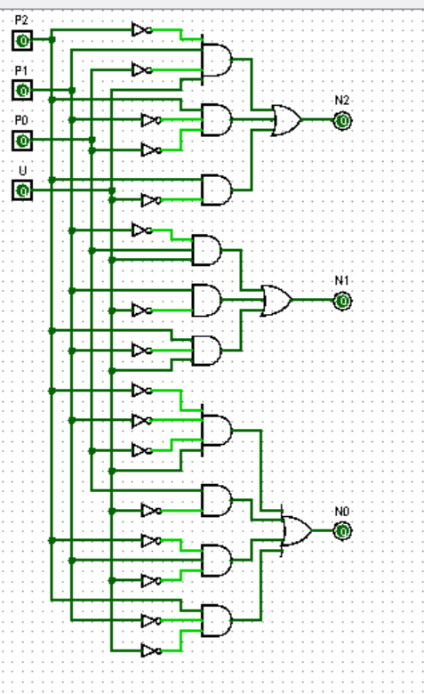

References:
- Difference between Mealy machine and Moore machine - GeeksforGeeks
- er.yuvayana.org
- “Computer Systems Organization & Architecture”, John D. Carpinelli, ISBN: 0-201-61253-4

